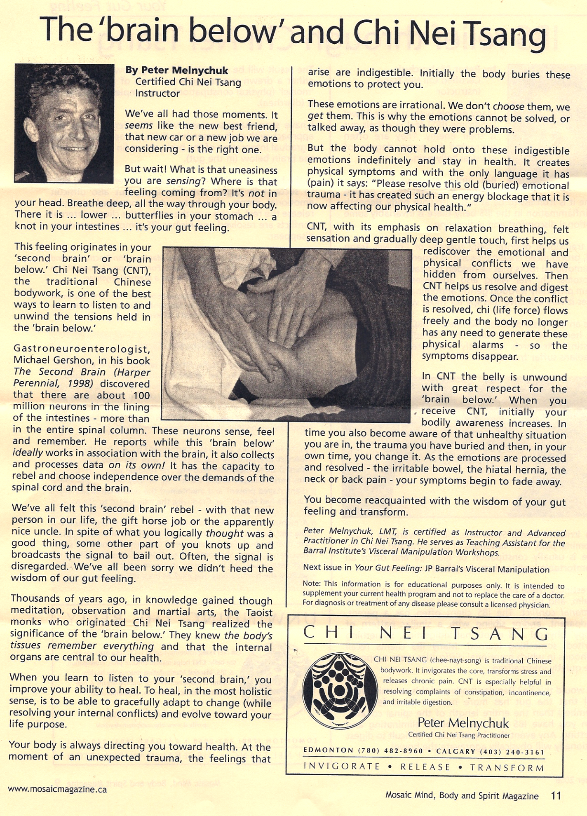
The brain below and Chi Nei Tsang by Peter Melnychuk

